**Questions 1-7**

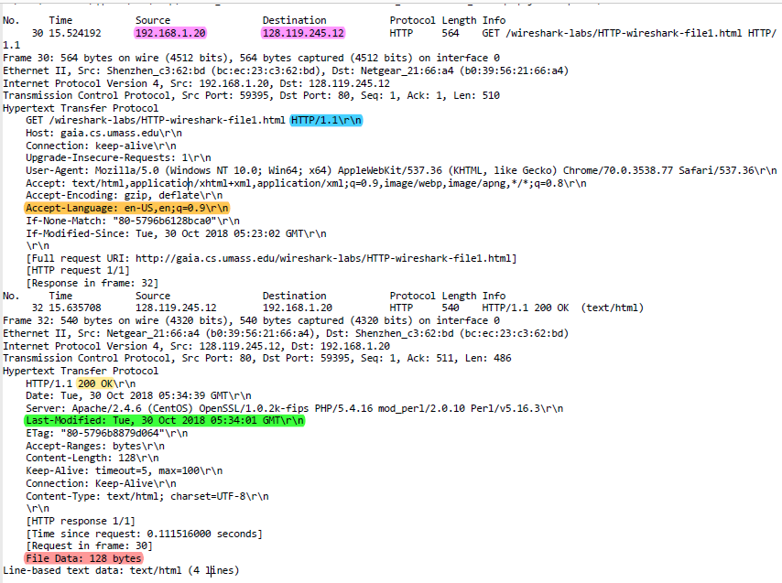

1. Is your browser running HTTP version 1.0 or 1.1? What version of HTTP is the

server running?

ANS: 1.1 (Blue Highlight)

2. What languages (if any) does your browser indicate that it can accept to the

server?

ANS: English (US) & English (Orange Highlight)

3. What is the IP address of your computer? Of the gaia.cs.umass.edu server?

ANS: My_IP 192.168.1.20 & Gia_IP 128.119.245.12 (Pink Highlight)

4. What is the status code returned from the server to your browser?

ANS: 200 OK (Yellow Highlight)

5. When was the HTML file that you are retrieving last modified at the server?

ANS: Tue, 30 October 2018 05:34:01 GMT (Green Highlight)

6. How many bytes of content are being returned to your browser?

ANS: 128 Bytes (Red Highlight)

7. By inspecting the raw data in the packet content window, do you see any headers

within the data that are not displayed in the packet-listing window? If so, name

one.

ANS. No I do not see any headers within the data.

**Questions 8-11**

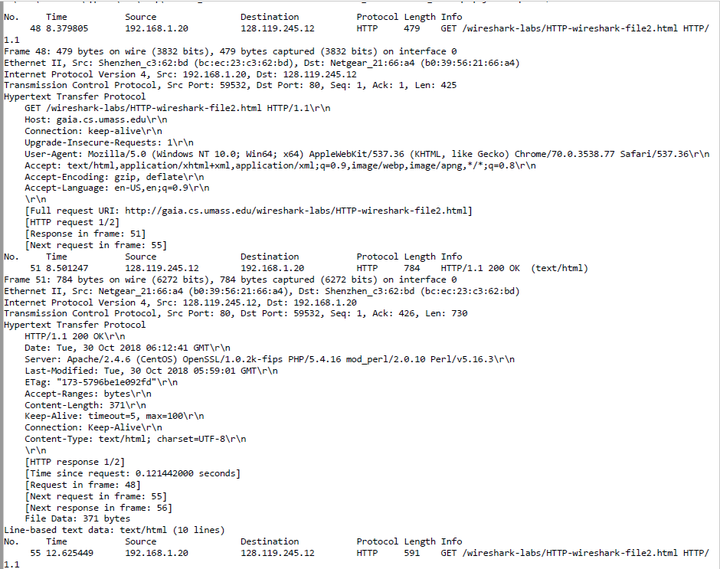

(First Request)

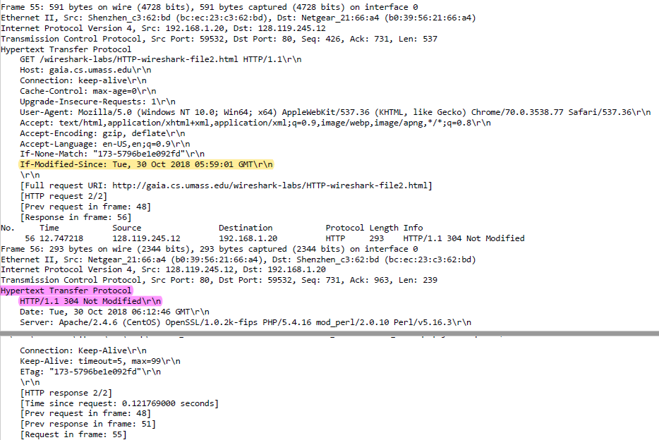

(Second Request)

8. Inspect the contents of the first HTTP GET request from your browser to the server. Do you see an “IF-MODIFIED-SINCE” line in the HTTP GET?

ANS: There is no “IF-MODIFIED-SINCE” line on the first HTTP GET

9. Inspect the contents of the server response. Did the server explicitly return the contents of the file? How can you tell?

ANS: I did not get this(figure below) content of the message for some reason. Using google chrome and cache was cleared

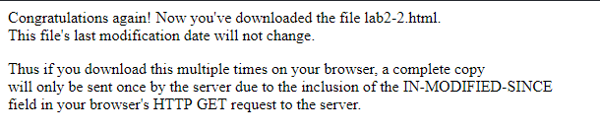

10. Now inspect the contents of the second HTTP GET request from your browser to the server. Do you see an “IF-MODIFIED-SINCE:” line in the HTTP GET? If so, what information follows the “IF-MODIFIED-SINCE:” header?

ANS: Yes there is an “IF-MODIFIED-SINCE” line followed by the date TUE, 30 October 2018 05:59:01 GMT (Yellow Highlight)

11. What is the HTTP status code and phrase returned from the server in response to this second HTTP GET? Did the server explicitly return the contents of the file? Explain.

ANS: HTTP code is 304 Not Modified (Highlight Pink). The server did not return the contents of the file due to the file not being modified.

**Questions 12- 15**

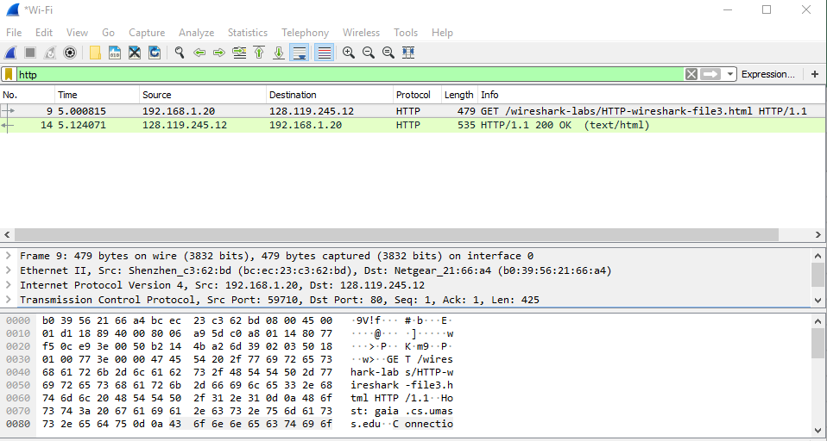

12. How many HTTP GET request messages did your browser send? Which packet

number in the trace contains the GET message for the Bill or Rights?

ANS: Google Chrome sent only 1 GET request. Packet 9 contains the GET message for the Bill of Rights (see figure above)

13. Which packet number in the trace contains the status code and phrase associated

with the response to the HTTP GET request?

ANS: Packet 14 (Please reference the figure above)

14. What is the status code and phrase in the response?

ANS: HTTP code 200 OK

15. How many data-containing TCP segments were needed to carry the single HTTP

response and the text of the Bill of Rights?

ANS: 4 Packets 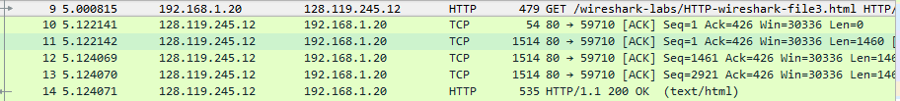

**Questions 16-17**

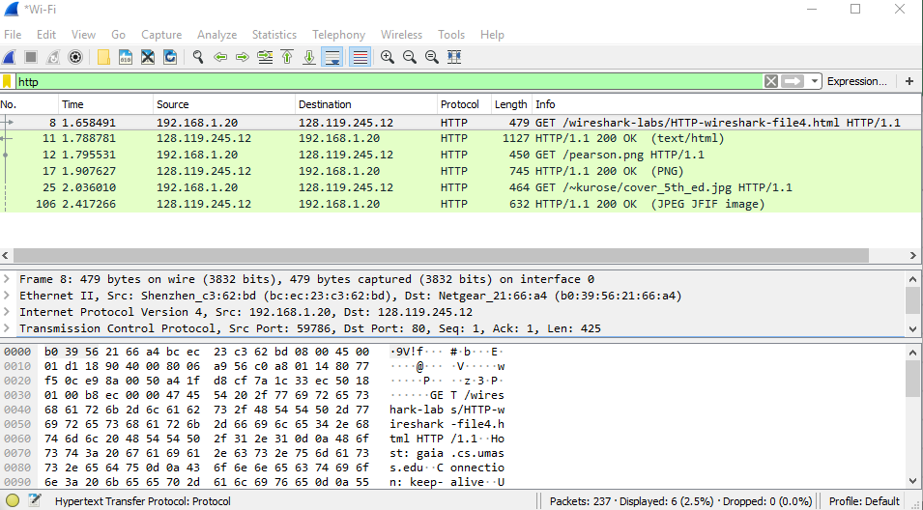

16. How many HTTP GET request messages did your browser send? To which

Internet addresses were these GET requests sent?

ANS: WireShark reported 3 HTTP GET requests. The first GET request was for establishing connection. The second and third were to receive the book cover for the 5th edition and pearson.png. All my GET Requests were sent to IP Address 128.119.245.12.

17. Can you tell whether your browser downloaded the two images serially, or

whether they were downloaded from the two web sites in parallel? Explain.

ANS: I assume the images were downloaded in parallel because of how fast information was received. It makes more sense to me to download in parallel because if you are downloading multiple images on a website, you want all of them to show up as soon as possible as oppose to serially. With serially if you have 1 large image to download and many small images next in line, then the small size images will have to wait for a while.

**Question 18-19**

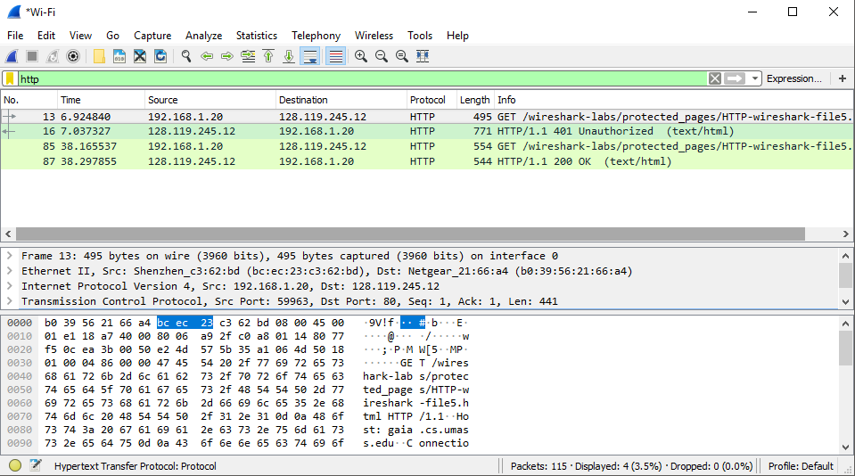

18. What is the server’s response (status code and phrase) in response to the initial

HTTP GET message from your browser?

ANS: Response to the initial GET request produces Status code 401 phrase Unauthorized

19. When your browser’s sends the HTTP GET message for the second time, what

new field is included in the HTTP GET message?

ANS: The new field included in the second HTTP GET message is Authorization. I have attached two images show the difference.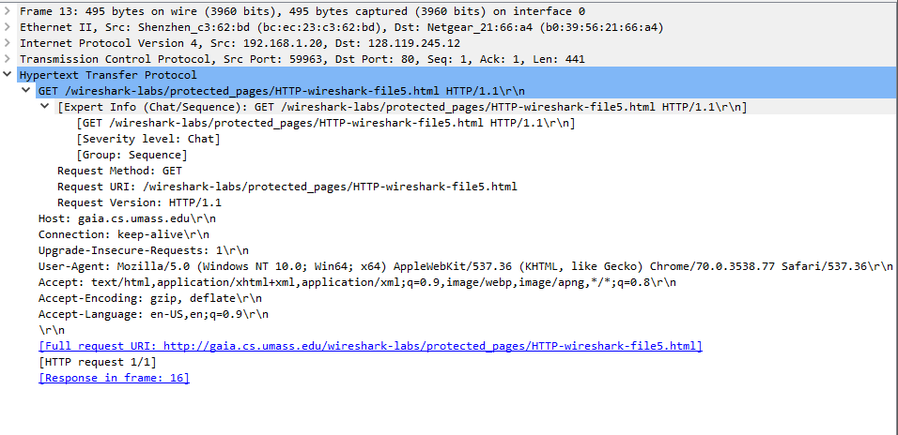

(First HTTP GET Request)

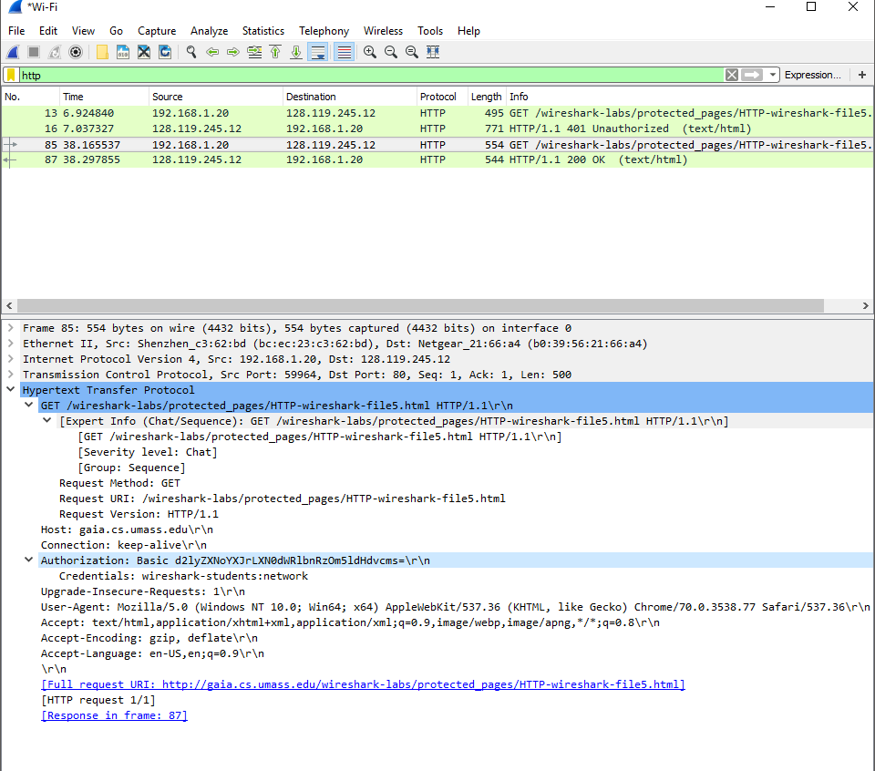

(Second HTTP GET Request)